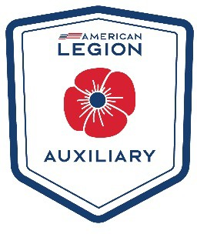

# POPPY POSTER CONTEST COVER SHEET

Each year, the American Legion Auxiliary (ALA) sponsors a Poppy Poster Contest for students in grades 2-12, including students with special needs. Grade levels are divided into seven classes. One award in each of the seven classes will be presented in each division. Winners will receive

$50 and a $50 donation in the student’s name will be made to the Children of Warriors National Presidents’ Scholarship fund. National winners will be posted at [www.ALAforVeterans.org](http://www.ALAforVeterans.org/) after national convention.

# Poster Classes:

**Class Grade Level**

1. 2 and 3
2. 4 and 5
3. 6 and 7
4. 8 and 9
5. 10 and 11
6. 12
7. Students with special needs

Class competing in:

Sponsoring ALA unit:

Due date for student to return to ALA unit:

# To Be Completed by the Student/Parent:

Student Name: Address (Street, City, State, Zip):

E-mail Address: Phone: School Name: City/State of School: Parent or Teacher Name and Signature:

**Auxiliary Use Only (Must be completed for entry to be considered.):**

Sponsoring Unit Name/Number: Signature of Unit Poppy Chairman/President:

Unit winner due to Department on: 4/15/26 Department: Virginia Signature of Department Chairman:

*Department winner due to National Poppy Division Chairman by June 1*

POPPY