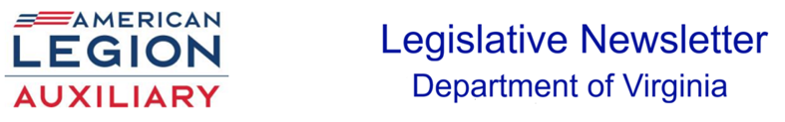
____________________________________________________________________
January 2026 Legislative Susan Oertel, Chair

“A Voice for our Veterans, Military and their Families”

It is an honor to serve those who have made such enormous sacrifices in service to this nation. As Auxiliary members we joined the ALA to honor those who served.
Have you communicated with your legislators using The American Legion’s Grassroots Action Center? The American Legion’s Grassroots Action Center will keep you informed on issues and provide you with resource tools to communicate online with lawmakers and the media about the AL priorities. https://www.votervoice.net/AmericanLegion/home
Some ways to contribute to our ALA Legislative program is by signing up for Action Alerts and meeting with your local and state representatives. Why not contact your local representatives and request a proclamation for one or all of the following:
January 19: Martin Luther King Jr. Day of Service
February 3: Four Chaplain’s Day - 1948 Congress designated 3 February as “Four Chaplain’s Day”
February 14: Valentine’s Day – Salute to Veteran Patients is the week of February 14

DAY ON THE HILL
January 15, 2026
8 AM

The Day on the Hill will take place at the General Assembly in Richmond. We will begin the day by meeting at Department HQ at 8 AM. A short briefing on the priorities will be discussed. This information will be available for you to share with your delegates and senators. Please contact your delegates and senators’ offices prior to January 15 to set up appointments for your visits. If they are unavailable, you may leave the information sheets with their legislative aides.
A bus will be available to the Capitol following the briefing. After your visit, please send me a brief email of your visit. Day on the Hill is open to all Legion Family members. legislative@vaauxiliary.org

WASHINGTON CONFERENCE
February 28 – March 4, 2026

The schedule for the conference:
March 2 – Legislative Commission Meeting and Commander’s Call
March 3 – ‘Know Before You Go’ briefs and Hill visits
March 4 - National Commander’s Testimony to Joint session of Congress

The Washington Conference brings together Legionnaires for critical discussions with lawmakers, informative sessions with members of Congress and insights on legislative priorities from the National Commander.
The Washington Conference is OPEN to ALL Legion Family members.

